TESTING DOCUMENT
8. TESTING PHASE

8.1 OBJECTIVE

The objective of testing is to verify whether the Script-Controlled ACLs are working correctly and whether users can access the records according to their assigned roles and the configured conditions.

8.2 TESTING PROCESS

The implemented ACLs are tested using different users and roles. The testing focuses on Read, Create, Write, and Delete operations.

8.3 READ ACL TESTING
The Read ACL is tested using the EEE User and other users.

Test Condition:
User with bb1 role can view the required EEE branch records.
User without the required role cannot view the records.
Administrator can view all records.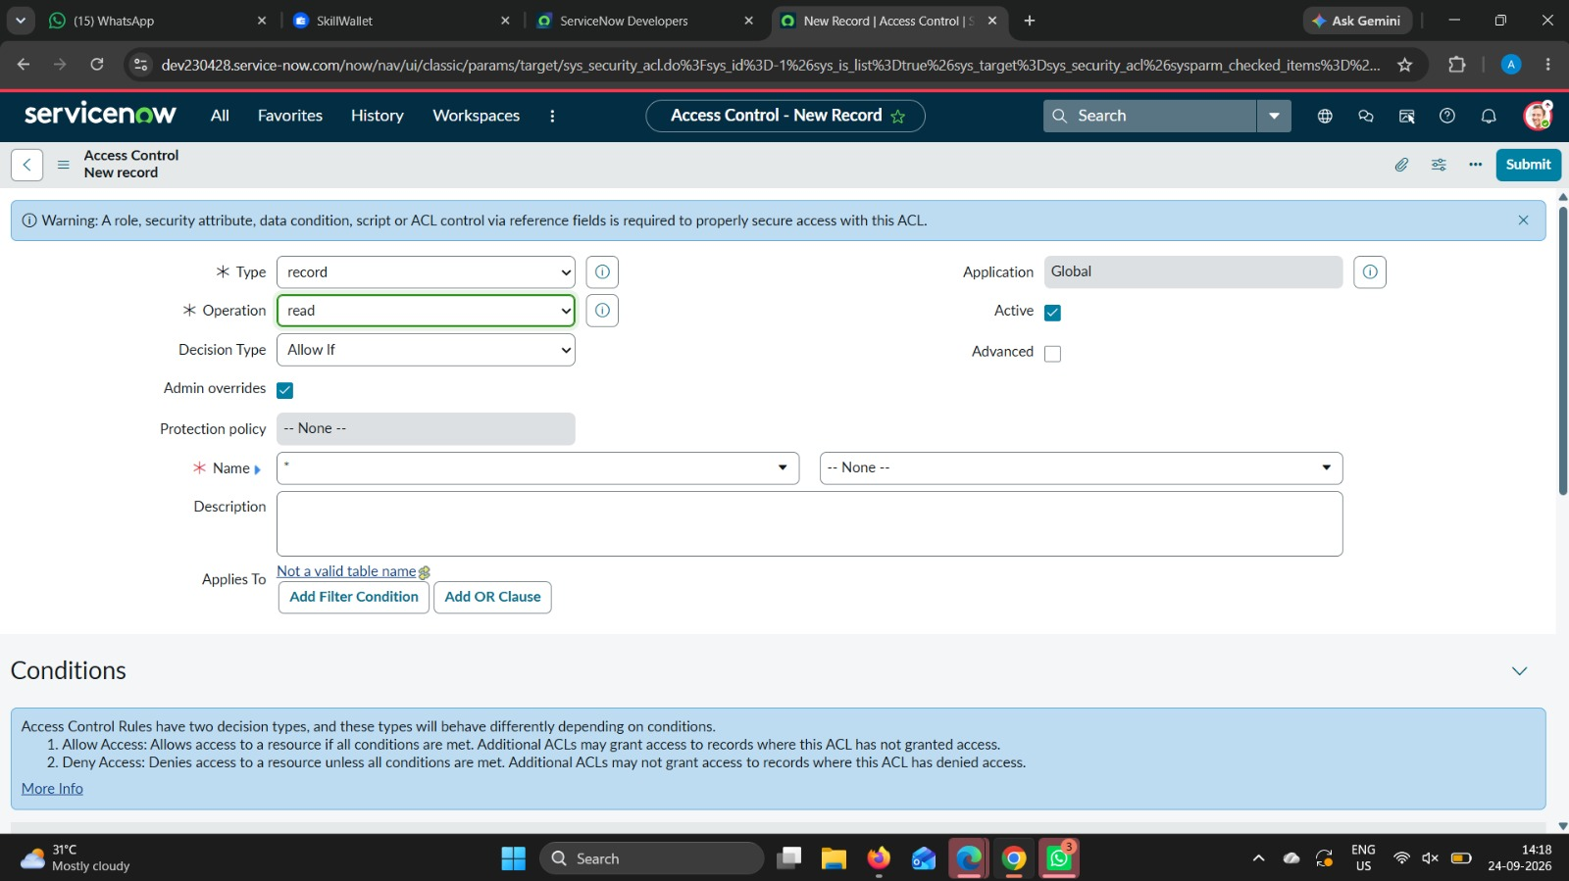

8.4 CREATE ACL TESTING

The Create ACL is tested using a user with the bb2 role.

Test Condition:

User with the required Create permission can access the New option and create records.

Users without the required permission cannot perform the Create operation.

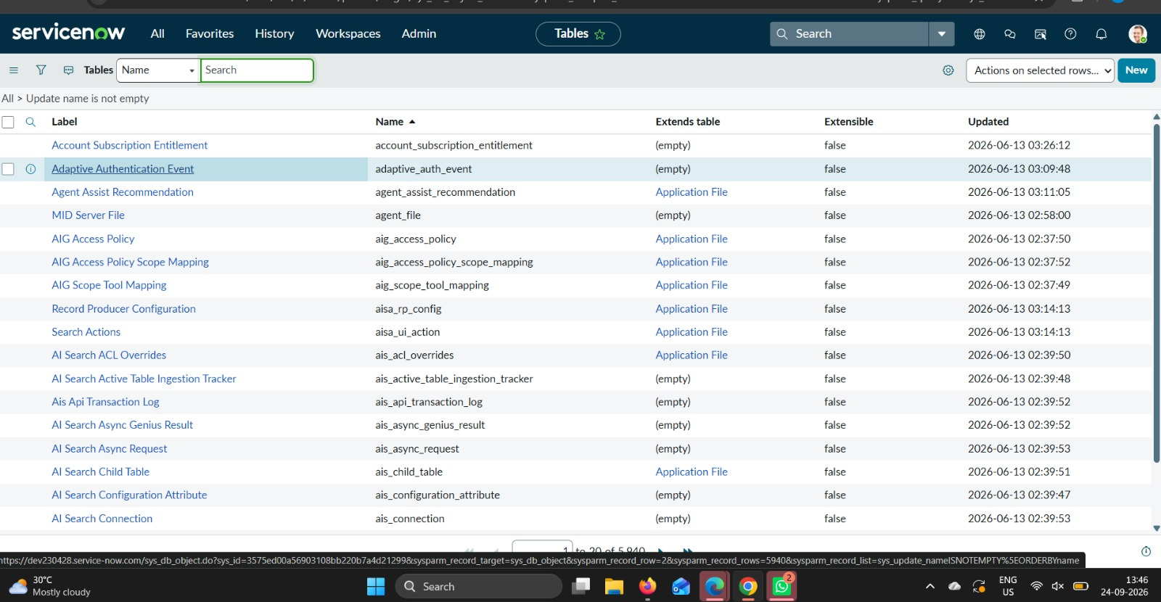

8.5 WRITE ACL TESTING

The Write ACL is tested using a user with the bb3 role.

Test Condition:

User with the required Write permission can edit the permitted records.

Users without the required permission cannot modify the records.

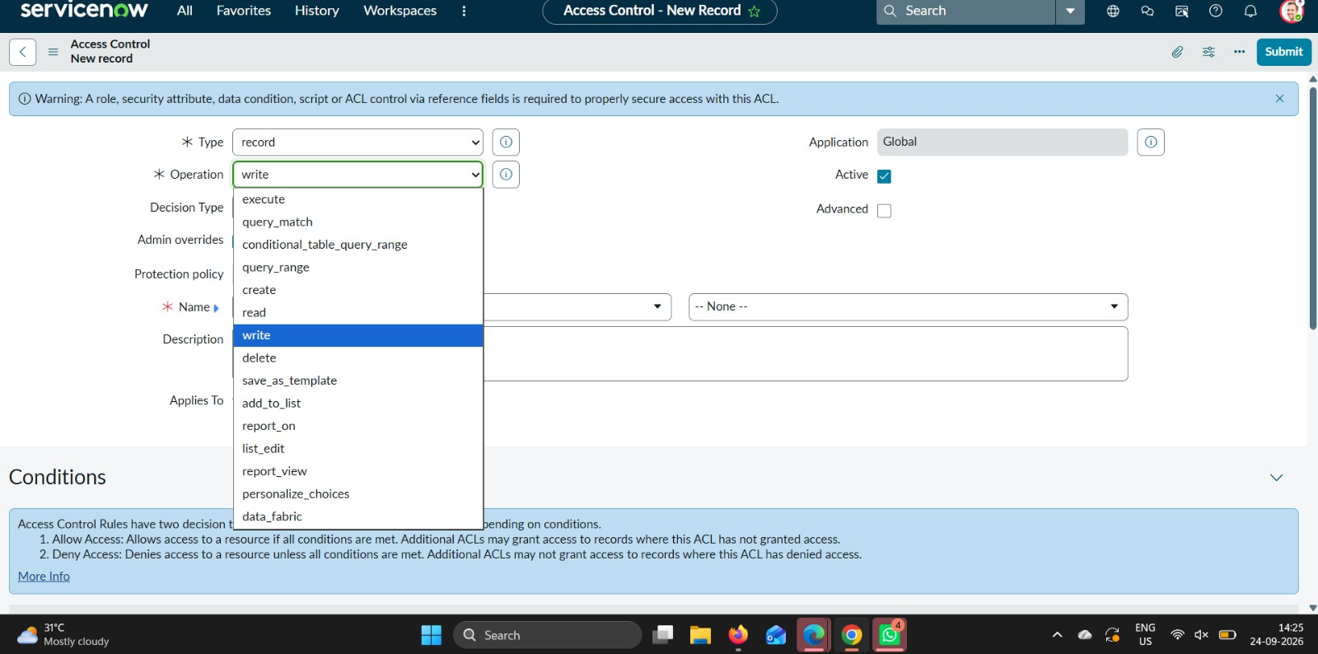

8.6 DELETE ACL TESTING
The Delete ACL is tested using a user with the bb4 role.

Test Condition:
User with the required Delete permission can delete the permitted records.
Users without the required permission cannot delete the records.

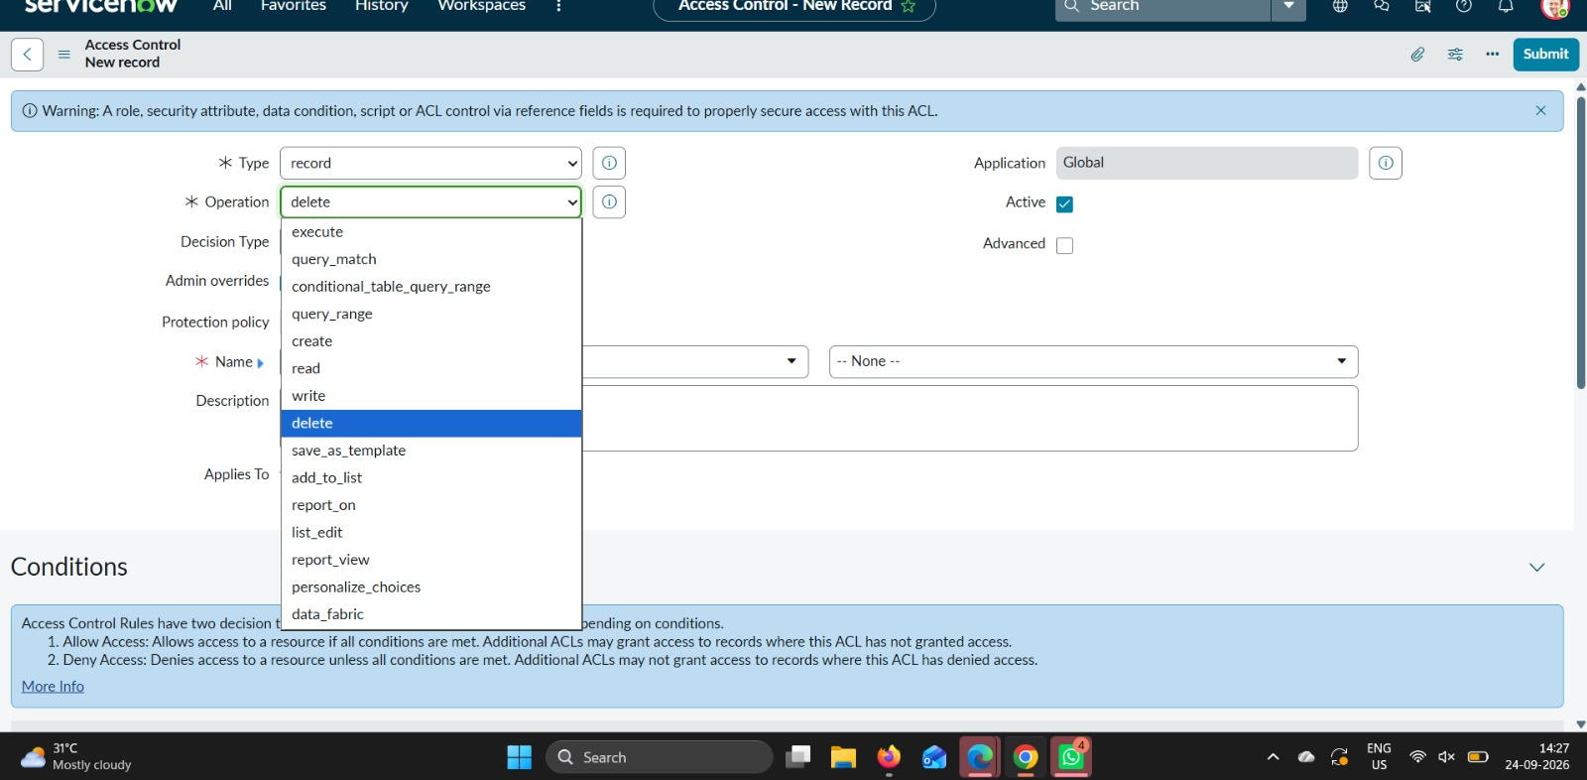
8.7 TESTING RESULT

The testing verifies that the configured ACLs control record access according to the assigned roles and conditions. The Read, Create, Write, and Delete operations are tested to ensure that unauthorized users cannot perform restricted operations.

8.8 CONCLUSION

The testing phase confirms the functionality of the Script-Controlled ACL implementation in ServiceNow. The system provides controlled access to records based on user roles and the configured branch condition.

